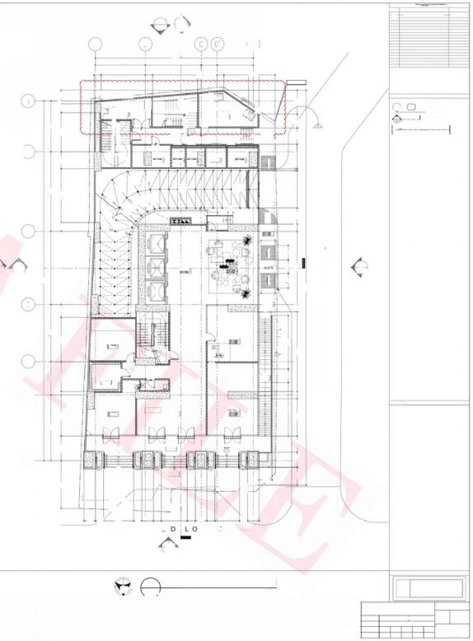**DRAWING REGISTRY**

DESCRIPTION

MARK

个

DATE

**DEC.10,2024**

WRTENDIMENSIONSONTHESEDRAWINGSSHALHAVEPRECEDENCEOVERSCALEDLLAT.SY TM(ARCHITECTURAEaCHNICAL,ETCusReAN2oNAuL.,5TRUC)SHALLTURAL,BESUBECToaosa5ANITARY,ELECTRICALFORVERIFICATIONsecnano0s,

SEESECTIONB

8920 5695

4137 2483 2715 000 1980 1205

6500 3260

6437

2300

40315

7350 3750 6400 8200

4200 400 2385 96540Q 5600 800 8200

.

ERTY LINE

4235 800 2035

7070 3359 3000 2019 7540

dOdd

2750

1700 1765

SEE SECTION'B'

5695

1900 4695 1000293 1200

面

(5

2% SLOPE

2750 1800 90 2655

40315

7350 3750 6400 8200 8920

5355 2750 4600 3350 4950 1450 6020

000l

1% SLOPE

1%S0H3了

975

009

dUNE OF BUILDINGABOVE

SLOP 12% SOFE

PROPER

制土

1500 650 1500 1650

0009 0009

800 1800 4200

4200 800 8950

44265

0028

A B R A

2000 1700 1800

穆④

页⑥

a G N 气

慌 S O F E D

供 S 0

新

飞

S

E

/

0

四⑤⑩

②①

①@0

EN

T

S

INCLINED COLUMNADJUSTMENT

2

A-501

A

1402

0

A B

17720

I

6250

5615

1815 4036

744 2745 547650 1787

798

4965

800

5050

440

REF.ELEVATION ±00

PROPERTY LINE

LEGEND:

①

四1791

1

MERALCO iACCESS

DRAWING NO.

SHEET NO.

SHEET TYPE(A/ME/P/FP/S)

oO⑨①STAIR

⑧⑥⑤④⑤②0

uP-

一BLOWER ROQM

FCC/SEC ROOM

般

⑩

CUITTING LUNE

o r 阿

示 ① (

MAICH LINE

世

拾

食

⑤o③②o

二

「R RU 二

「RUD 二

(2

P ④

③

EE ROOM

WET

SPECIAL

◆HL=100w

◆SSL=9500M

DRY

SL-950M

REC

52=950W

F.E/1

552=100W

SSL=950MN

席SOPE



1150

博 5OPE

13 SOPE

dLNE Of FIRE RESERVE TANK BELOW

euP

段

%SLOPE

3

SLP

1600

A

2402

SEE

SECTION'A'

E4 LEVATOR LOBBY

TL=1000N

A

2|40y

1

A-501

cf-ur

DRAN

量

1600

SEX1

4

摄

1360

RAMg uP

I|

⑩ ⑨

PROWSON FOR STORAGE

⑥ ⑤ ④ ③

>

RETAIL 3

ADMIN

52=950W

面

D:回

u

P

F

2

5

LANDING

M AIL

ROOM

coMMON TOLET

=9dm :

Poo Toue

O

66

**KEYPLAN:**

LOBBY

中FfL=1000WM

SSL=950M

RETAIL 1

L=950W

8.

ARCADE

-90n

⑦

4

1450

duNE oF BULDING ABOVE PROPERTY

nE

1

dLNE GF EULDING POE

dBROPERTY LNE

900 3400 900 **N A** T I **V**

DROP OFF AREA

2750 900

Z S **T.**

300 900 2905 900

I **D A**

900

E

13po

1250

13bo

P

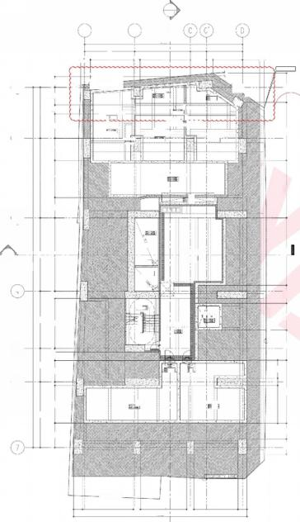

2

A-501

A

17720

6250 1815 4036

700 5650 714 3322 1936 500

REF.ELEVATION ±00

peoeer

PROPFRKY

ASD ANOXIC

TANK *L/NF*

65

C A W L jK

-160

S E w N E

(VERIFYTINON FbwRATE)

SBR-TTANK

-SBR-2-ANK-

WATER.DEP504500 MM.- WATER DEPTH 三 4 5 0 0 _MM

BELOM

FIRE RESSERVE TANk

3

0

品

SEE

SUMP_ PIT

SUMP_ PIT

2

3B0MW

cOMMERMCIAL

P[u MBIN G PψMP ROOM

I

UP

⑤

6

CISTERNl

iANK1

dPROPERTY LINE

1000 5705 800 5200 800 4950 10po

19455

1 SECTION'A' A-501

IEMPOCTOIO

婴

.E.±5000_MM.

S8=-6750M 65N

EQUIPMENT ROOM 50

①

EQT TANK BELOW

S5=-6750W

②

CISTI ERN TANK 2

397700

BSCFN

B

4865

5615

K

4

**DRAWING PHASE:**

S

3十

N

N

1 SUBSTRUCTURE

SCALE:

FL ○OR PLAN

1:100 M

s

CROUND

M

FLOOR

PLAN

1:100 M

2

A 301

**FOR CONSTRUCTION BULLETIN**

ASYA ASYA

升m

3十

SCALE:

*A 30*

N

ASYA

N

**SHEET NO.**

A 301

TOTAL SHEETS

173

SUBSTRUCTURE &GROUND FLOOR PLAN

MAR 2024 SCALE AS SHOWN PROJ# GRF

ER T T T T T

ER

|  |  |  |  |  |  |  |  |  |  |  |  |  |  |  |
| --- | --- | --- | --- | --- | --- | --- | --- | --- | --- | --- | --- | --- | --- | --- |
| **△SYA** | SEAL NOTE DESIGNER  THIS DRAWING ACTING AS AN WRITTEN DIMENSIONS ON THESE DRAWINGS SHALL HAVE PRECEDENCE ALLAN C.CHUA  REPUBLIC ACT 9266  PSTPURENOF ASYA SESIGC PARINERRE.SPONSIBLE FOR ALL DIMENSIONS AND CONDITIONS ON THE JOB.THE  OVER SCALED DIMENSIONS.CONTRACTORS SHALL VERIFY AND BE | | | | | **STRUCTURAL** **E**  **Jct** | **NGINEER**  R**OBERT** **CHRISTOPHERA.NIEBRE** | **SANITARY** **ENGINEER**  J**UAN** **CARLO** **NORBERTE** S | **FIRE** **PRO** **ENGINEER**  **WI** L **FRED** A**BROGENA** | **ELECTRICAL** **ENGINEER**  **STEPHEN** **NAPE**ŇAS | **MECHANICAL** **ENGINEER**  WILFRED ABROGENA | **PROJECT** **TITLE** **AND** **LOCATION** | **LAND** **OWNER** **&DEVELOPER** | SHEET  CONTENT |
| APLAGCE ASIA CGMPLeR,CBP-YA 72/85-05  EMAlL ADD.asyo@usyadeslgn.com.ph | DuSsucn MEpF  SAID DOCUMENTS FOR USE IN THE REPETITION OF AND FOR OTHER PARILECTSRIN WHDLEWTHou CHER CONSENT.ALL DRAWINGS ARE TO BE RETURNED WHEN NO LONGER IN USE. | DESIGNER MUST BE NOTIFIED IMMEDIATELY OF ANY VARIATIONS FROM THE DIMENSIONS AND CONDITIONS SHOWN BY THESE DRAWINGS.  ANY DISCREPANCY ON ALL DRAWING &SPECIFICATIONS  (ARCHITECTURAL,STRUCTURAL,SANITARY,ELECTRICAL &MECHANICAL) SHALL_BE SUBJECT FOR VERIFICATION AT THE ARCHITECT's OFFICE BEFORE IMPLEMENTATION. | REG.NO:0023165  PTR.NO:8453438 | ARCHITECT  TIN:  DATE: | 289-222-941  01-03-2024 | 2302C East Tower PSE Certre,Echong od otos cco24010 a iroeqnoutoon | STRUCTURALENGINEER e  REG.NO.011903 TIN 273548-50 PTR NO.1007400 DATE 01-0424 PLACE MAKATICITY | SANITARY ENGINEER  0REG.NO:0002835 TIN: 319-240-799  PTR.NO:8453437 DATE: 01-03-2024 | MECHANICAL ENGINEER  REG.NO:0004781 TIN: 215-380-265  PTR.NO:8453436 DATE: 01-03-2024 | ELECTRICAL ENGINEER  REG.NO:0004290 TIN: 242-781-694  PTR.NO:8453439 DATE: 01-03-2024 | MECHANICAL ENGINEER  REG.NO:0004781 TIN: 215-380-265  PTR.NO:8453436 DATE: 01-03-2024 | GALE **RIES** **TOWER** **MANILA**  NATIVIDAD LOPEZ STREET COR.CABRAL STREET,MANILA | **GRAND** **TAIPAN** **LAND** **DEVELOPMENT,INC.** | CADD  CHECKED |
| APPROVE |

DATE D

I [192.168.2.203\production-othersOthers-Galeries\011 EDIT FILE\100%FCD Plans\03 AR FCD\CADA-300 Floor Plans\301 Substructure &Ground Floor Plan-FOR CB001.dwg](192.168.2.203\\production-othersOthers-Galeries\\011EDITFILE\\100%FCDPlans\\03ARFCD\\CADA-300FloorPlans\\301Substructure&GroundFloorPlan-FORCB001.dwg)

|  |  |  |
| --- | --- | --- |
|  | DRAWING REGISTRY |  |
| MARK | DESCRIPTION | DATE |

个 INCLINEDCOLUMNADJUSTMENT 10,2024

DEC.

ANDcONDITDIMENSIONSDSATIONSONSONTHEJOBcONTRACTORSPRECEOVERTHESHALLVERIFYDESIGNERSCALEDANDcONDANDMUSTBEBERESPONSIBLENOTIFIEDIMMFOITIONSSHOWNBYTREHESEDALLIATELYDIMENOFSIONSANYDRAWINGS. TM(ARCHITECTURAECHNICAL,ETCausReAN2oNAuL.,5TRUC)SHALLTURAL,BESUBECToaosa5ANITARY,ELECTRICALFORVERIFICATIONsecnano0s,

SEESECTION8

5695

2288 5733 2187 4451 100025 1193

SLOPE

博下0FE口

BLEND-

1第S0

1217

RMP 102NOF00

800 6420 1497 3200 3888

40315

7350 3750 6400

4809 8660 2139 582

N7

ROPERTY

19.50%

SLOPE

幼三3d07S

SLOPE

幼三30S

w飞QE

S0PE

8200

44265

PROPERTY LINE

800 8950

0009

3700 1f0o

A

2000 1410

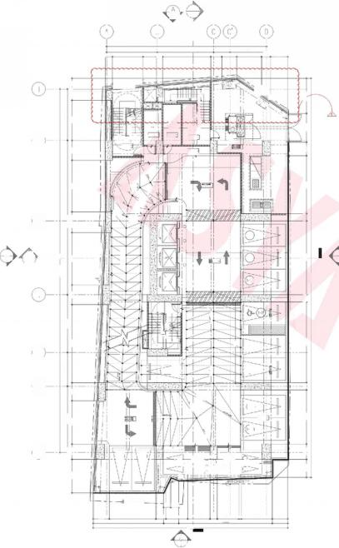

2

1402 A-501

B

17720

6250 I

5325

700。

PROPERTY LIN

PRORERTY

户C

◎⑩ ⑩ 起 延 延 ①

TRANSFORMER

ROOM

2

道

霞

FF

MERALCO ACCE$S

◆HL-55DOWN 882-56n

F.E.

中 L=5500MM

55L-5500W

般

长

+SSL=550WM

18 SLOPEE

18 SLOPED

1 SLOPEc

RAMP UP

1 SLOPEE

③

Pe 1-01

4150 920

DROF-OFF

1-02-

A-501

O

-03)

O

4

g 调

⑨ ⑩2|①

中 =6411M

+SSL=6361M

1-04

1-05

6

1席 SOPE

060

摄

0

1200MM HIGH PARAPET WAL

1-03

MOTORCYCLE

PARKING SLOT

INE

ROPERTYLINE

805 880

1110 2400 2490 80o 2400 259 3441 1710 1685 10358 1710

21551

A

1 401

1815 4036

h238 1645 2746 95 1911

⑦

01

MOTORCYCLE PARKING SLOT

5615

3387 1478

RoO0M

◆FL=5650WN 5L=5600N

⑩ 面⑧①⑥ ④ ⑤②①

②

⑩ ⑩ 0

透 ⑩

② .

⑤

10

A

2 401

A 2402

ROOM

◆FL=5650MM

◆SSL=5600W

160po

B

BICYCLE RACK

书

再

②③④粤 ⑥

A O

00

SECTION'A

530

RAMP UP FROM GRORUND FL00R

通 面

⑤

② 品

0298

1 SOPE

1772

SEE

798

STAIR

o

1

7798

5169

F. .E.

04

人

丝

0

SLOPE ·

A

2

l

*L.*



A

2402

SEE SECTION8

5695

2197 4470 203

000

209

3888

2527 3200

507

8920

2298 5723

40315

7350 3750 6400 8200

4800 2000 865 2199 5802

00L2

N 行

编50FE

博飞0FE

iL0

体乳0FE

SLOPE 11.01%

PARAPET WALL

体SIo元

RAAP UP T03RD FL0OR

1g90t

SLOPE= 4% SLOPE= 4%

NOPAPKNG

3100 2300

8200 6620

44265

P R O P E R T 人

2000 1700 6000 800 8950

LEGEND:

① DRAWING NO.

四1791 SHEET NO.

SHEET TYPE(A/ME/PFP/S)

CUTTING LINE

MATCHLNE

**KEYPLAN:**

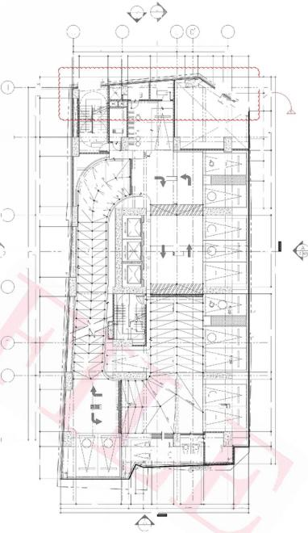

A

1402

B

17720

6250 I

2600 ↓700

IN

STORAGE

.

◆FL=8800MM

◆fL=8950WN

HL8900W

MNNMNMNMMI

Q

⑥

05

EE

ROOM

89560

UP

10

20

(214)

Q

X

1第 SLOPEL

2-02

sLoPE

13 SOPE

R8

P大

2-03

O

O

4150

OFF

8

2-05

o

4

品

DN

2-15

=-971MN

◆SL=9661M

2

2-06

2

5

2-07

6

RAMP UP FROW 1sT FL0OR

&OPg

2-08)

开

◆SSL=835DM

2-00

1260 MM HIGH PARAFET WALL

8

T

2-11 2-10

IELCO

2

-

PARKING SLOT

MOTORCYCLE PARKING sLoT

LINE

dPROPERTYLINE

805 880

1772 5169 1110 2400 2490 800 2400 259 3441 1710 7798 1685 10358 1710

2155

A

1 401

临 =3d07S A

5615

3322 1553

②

PROPERTY

06

07BICYCLE

RACK 09

4036

1732 1164

⑦

1

A-501

①r ② ③

⑥ ② ⑧ ⑨

BICYCLE

RACK 3

⑩矿⑧⑦ ④③②①

b 5 5 墙 ①⑫

95 1911

160po

DRO中-

SEE SECTION'A

→ 十 十

AU文 ROOM

中 FRL=8650MM

SSL=8650uu

dPRORERTY

◆FFL=8800MW 55L=8250M

②⑫ 品

华3d07S

5⑩ ⑩ 阿

中十798

MOTORCYCLE

3

A-501

Q



C

BEen

D

ROOM

1815

1495

13 SLOPEE

sE×

A

04

摄

EN

第夏OPE

SSL-8750W

品

3963

(04

(03

1

将

2

EE

920

十

U

素

F.I

**DRAWING** **PHASE:**

4 1ST

*A 3025CALE*

PLAN

FL○OR

M

3

1:100 M

D



AN

1:100 M

N

□ LOOR

2ND

SCALE:

2

A 302

3 M

D

|  |  |  |  |  |  |  |  |  |  |  |  |  |  |  |
| --- | --- | --- | --- | --- | --- | --- | --- | --- | --- | --- | --- | --- | --- | --- |
| **△SYA** | SEAL | NOTE | DESIGNER | | **STRUCTURAL** **E** | **NGINEER** | **SANITARY** **ENGINEER** | **FIRE** **PRO** **ENGINEER** | | **ELECTRICAL** **ENGINEER** | **MECHANICAL** **ENGINEER** | **PROJECT** **TITLE** **AND** **LOCATION** | **LAND** **OWNER** **&DEVELOPER** | SHEET  CONTENT |
| REPUBLIC ACT 9266  THIS DRAWING ACTING AS AN  PRSOPEUMENToF ASYA DESYiC PARINER. DuSsucn MEp  SAID DOCUMENTS FOR USE IN THE  REPETITION OF AND FOR OTHER  PARILECTSRIN WHDLEWTHou CHER  CONSENT.ALL DRAWINGS ARE TO BE RETURNED WHEN NO LONGER IN USE. | WRITTEN DIMENSIONS ON THESE DRAWINGS SHALL HAVE PRECEDENCE  OVER SCALED DIMENSIONS.CONTRACTORS SHALL VERIFY AND BE  RESPONSIBLE FOR ALL DIMENSIONS AND CONDITIONS ON THE JOB.THE DESIGNER MUST BE NOTIFIED IMMEDIATELY OF ANY VARIATIONS FROM  THE DIMENSIONS AND CONDITIONS SHOWN BY THESE DRAWINGS. ANY DISCREPANCY ON ALL DRAWING &SPECIFICATIONS  (ARCHITECTURAL,STRUCTURAL,SANITARY,ELECTRICAL &MECHANICAL) | ALLAN C.CHUA  ARCHITECT | | U cE  2302C East Tower PSE Certre,Echong | ROBERT CHRISTOPHERA.NIEBRES STRUCTURALENGINEER  e | J **UAN** **CARLO** **NORBERTE**  SANITARY ENGINEER | **WIL** FRE **D** **ABROGENA**  MECHANICAL ENGINEER | | **STEPHEN** **NAPE**ŇAS  ELECTRICAL ENGINEER | WILFRED ABROGENA  MECHANICAL ENGINEER | GALERI **ES** **TOWER** **MANILA** | **GRAND** **TAIPAN** **LAND** **DEVELOPMENT,INC.** | DATE |
| CADD |
| APLAGCE ASIA CGMPLeR,CBP-YA 72/85-05  EMAlL ADD.asyo@usyadeslgn.com.ph | CHECKED |
| SHALL BE SUBJECT FOR VERIFICATION AT THE ARCHITECT's OFFICE BEFORE IMPLEMENTATION. | | | REG.NO:0023165 PTR.NO:8453438 | TIN: 289-222-941  DATE: 01-03-2024 | od otos cco24010 a iroeqnoutoon | REG.NO.011903 TIN 273548-500 PTR NO.1007400 DATE 01-0424  PLACE MAKATICITY | REG.NO:0002835 TIN: 319-240-799  PTR.NO:8453437 DATE: 01-03-2024 | REG.NO:0004781 PTR.NO:8453436 | TIN: 215-380-265  DATE: 01-03-2024 | REG.NO:0004290 TIN: 242-781-694  PTR.NO:8453439 DATE: 01-03-2024 | REG.NO:0004781 TIN: APPROVE  NATIVIDAD LOPEZ STREET COR.CABRAL STREET,MANILA  PTR.NO:8453436 DATE: 01-03-2024 | | | |

215-380-265

**FOR** **CONSTRUCTION** **BULLETIN**

ASYA ASYA

ASYA

**SHEET** **NO.**

A 302

TOTAL SHEETS

173

1ST &2ND FLOOR PLAN

SCALE AS SHOWN PROJ#

T T T T

MAR 2024 GRF

T

ER

ER

I\ [192.168.2.203\production-others\Others](192.168.2.203\\production-others\\Others) -Galeries\05 SITE FILES\01 Site Concerns\04 Construction Bulletin\2025\02 FEB\CB01\CADFILES\3021st &2nd Floor Plan.dwg

MARK

个

DRAWING REGISTRY

DESCRIPTION

INCLINEDCOLUMNADJUSTMENT

DATE

DEC.10,2024

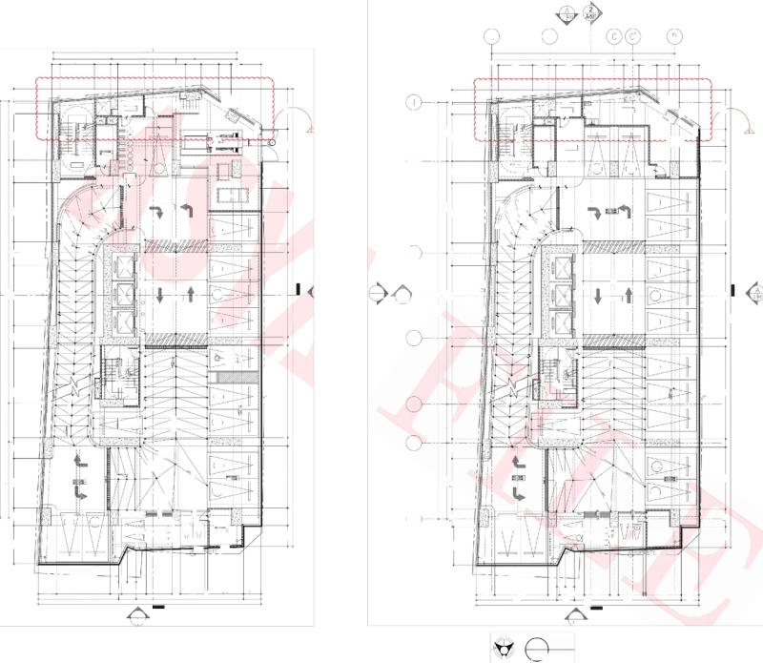A

2 A-501

1

402

SEE SECTION.B

D

A

B

17720

17720

6250I 2600

5615 6250 I

4036

1732 1164 995 1911

1815

4036

1732 1164

1815

5615

3312 1553

95 1911

798

3963

1495

700

798 3312 1553 700 2600 3963

1495

LEGEND:

E

2198 4499 100019 1203

2103 4527 1000 166 1203

①

四 1 7 9 1

DRAWING NO.

PROPERTY LINE

PROPERTY LIN

SHEET NO.

dPRORERTY

SHEET TYPE(A/ME/PFP/S)

AUX ROOM

AUX

ROOM

dPRORERTY

N →

⑦ ⑥⑤④③②①

4 P.C.

1

◆FFL=12250MM

2527 3200 3888

o

CUTTING LINE

4143 665 3807

◆FFL=15550MW *55L=13500M

户.C.

LNE

+SSL=12200WN

D

MAICH LINE_

① ⑩ 面(8

eC

②应

⑩

5695

上 品

0

5695

页

0

疆

⑩

商

⑥

⑦

⑦ ⑥

④

.

ADMIN OFFICE

⑥

k

e

④

05

⑩

5 l ⑥.

② ②

C

EXTENSIN

GE

rdbM

4

EE ROOM

EE

ROOM

5

③②①

③②①

BICYCL 日

1

拉

7 RACK

SS=12200MM

②

09

F.E.1

10)

◆H=12100MM

SSL=12060WN

40

上

二 二

中 FFL=15400MW

55=1550MM□

3-01

4-01

FTD

中FFL=12100MM

5bL=12100WN

sLOPE

3 S I O P E

章

GSG

情s0PE

8950 800 3100 2300

RMP ro5iH40K

403

8920

博飞0PE

!

O

◆HL=11950W SSL=11950MM

00

2199 5802 2299 5722

BEN0。

1% SOPE

1900 8949 1900 5901 2199 5817

S0F

8200 5400

黄 1

1第 S.0PE

RAMP UP TO4TH FL

LN

1 SLOPE

选 5 0 M 3

1第皇OPED

(4-04)

502)

18 SOPEE

18 OPE

189.0PEC

8SL0PEL

1信SOPEE

这 复 0PE

uD

第 又QPEE

18 SOPE:

中

③

18 S0e

品

1多SOPE

o

o

4.05)

PEX

3-03

PEX

O

o

O

4150

N7

i60Do

920

920

4150

ioo

DROF- -OFF FFL=15400MM

O

8200

8200

PROPERTY

TRE POR

/ , o s

信 , o 3

岂

A

A 2402

A 2402

4-06

1

A-501

1

A-501

8

DROF-OFF

◆IL=12100WN 522100W

SEE SECTION 'A

SEE SECTION'A

2

3-04

PE

40

PE×

32=1540NN

O

40315

40315

O

44265

44265

4-07)

3-05

SEx

SEx

O

4

中

品

UP

UP

6H

3NI7

酬

营 十

1

⑤

4208

7350 3750 6400

7350 3750 6400

PROPERTY LINE

燠

恤

Q②

进 牛

④ ⑤

⑥

ROPERT

后

①

③

L 1

⑨ 凹⑫

MO bVBKIMC

6000 800 8950

⑫

400

4799 2001 8650

BLEND 10.86%

0006

4980 3d07S

o⑩

o|D

L2y

5-06

507

F.E.

F.E2

5

=3d07S

4-00

SLOPE=4%

%三OL飞F

3-12)

琴

4

BLEND=7%

SLOPE:

KEYPLAN:

6

RAMP UP FRON zD L00R

FLoo

RAMP DOW TO RD

口18 SOPE

SLOPg

sc3

4-11

0009

308

SLO

SLOPE:

SS=

006t

(4-12)

1 SLOPE

3-09)

120 Mu HGH PARA²ETL.

1400

2000 1700

004

700

. 1200 MM HIGH PARAPET

⑦

(04

司二

(3-10

414

TELCO_2

58=1850W

3-0

:

0

MOTORCYCLE

PARKING SLOT

(03

MOTORCYCLE

@

午

申 典

MDFF

◎

MOTORcYCLE PARKING SLOT

0

0

3

PARKING SLOT

TausReAN2oNAuMECHNICAL,ETC(ARCHITECTURAL.,5TRUC)SHALLTUBRoEASUL,aBECT5ANITARY,ELECTRICALFORVERIFICATIONosasecnano0s,

2000

a3

3700

3700

02 ⑬

BICYCLE( RACK

零

BICYCLE

RACK

MCTORGYCLE

PARKING SLOI.

PROF

LIE

LINE

dPROPERTYLINE

dPROPERTYLINE

805 880

05 880

DIMENSIONS. cONTRACTORS SHALLVERIFY AND BERESPONSIBLE FOR ALL DIMENSIONS

ANDcONDITONSONTHEJOB.THE DESIGNER MUSTBE NOTIFIEDIMMEDIATELY OF ANY

VARIATIONSFROMTHE DIMENSIONS AND cONDITIONS SHOWN BYTHESE DRAWING.

1772 5169 1110 2400 2490 800 2400 25 3441 710

1772

1710

1710

800

3440

5169

2400

1110 2400 2490 1685

2155

7798 1685 10358 1710

7798

10358

2155

A

A

1 401

40V

**DRAWING** **PHASE:**

s

s

WRTEN DIMENSIONS ON THESE DRAWINGSSHAL HAVE PRECEDENCE OVER SCALED

P LAN

4

FLOOR

3RD

SCALE:

LOOR

PLAN

4TH

SCALE:

2

*A 303*

**FOR** **CONSTRUCTION** **BULLETIN**

M

ASYA ASYA ASYA

3+

3 十

N

1:100 MTS

1:100 MTS

A 303

N

DATE

**SHEET** **NO.**

3RD &4TH FLOOR PLAN

A 303

TOTAL SHEETS

173

MAR 2024 GRF

ER

ER

SCALE AS SHOWNPROJ#

T T T T

T

|  |  |  |  |  |  |  |  |  |  |  |  |  |  |
| --- | --- | --- | --- | --- | --- | --- | --- | --- | --- | --- | --- | --- | --- |
| **△SYA** | SEAL  REPUBLIC ACT 9266  THIS DRAWING ACTING AS AN  PRSOPEUMENToF ASYA DESYiC PARINER.  DuSsucn MEp | NOTE  WRITTEN DIMENSIONS ON THESE DRAWINGS SHALL HAVE PRECEDENCE  OVER SCALED DIMENSIONS.CONTRACTORS SHALL VERIFY AND BE  RESPONSIBLE FOR ALL DIMENSIONS AND CONDITIONS ON THE JOB.THE | DESIGNER  ALLAN C.CHUA | **STRUCTURAL** **E**  **U** | **NGINEER**  ROBERT CHRISTOPHERA.NIEBRES STRUCTURALENGINEER | **SANITARY** **ENGINEER**  J**UAN** **CARLO** **NORBERTE** | | **FIRE** **PRO** **ENGINEER**  **WI** LFRED **ABROGENA** | **ELECTRICAL** **ENGINEER**  **STEPHEN** **NAPEŇAS** | **MECHANICAL** **ENGINEER**  **WILFRED** **ABROGENA** | **PROJECT** **TITLE** **AND** **LOCATION**  GALE **RIES** **TOWER** **MANILA** | **LAND** **OWNER** **&DEVELOPER** | SHEET  CONTENT |
| APLAGCE ASIA CGMPLeR,CBP-YA 72/85-05  EMAlL ADD.asyo@usyadeslgn.com.ph | SAID DOCUMENTS FOR USE IN THE REPETITION OF AND FOR OTHER  PARILECTSRIN WHDLEWTHou CHER  CONSENT.ALL DRAWINGS ARE TO BE RETURNED WHEN NO LONGER IN USE. | DESIGNER MUST BE NOTIFIED IMMEDIATELY OF ANY VARIATIONS FROM THE DIMENSIONS AND CONDITIONS SHOWN BY THESE DRAWINGS.  ANY DISCREPANCY ON ALL DRAWING &SPECIFICATIONS  (ARCHITECTURAL,STRUCTURAL,SANITARY,ELECTRICAL &MECHANICAL) SHALL BE SUBJECT FOR VERIFICATION AT THE ARCHITECT's OFFICE | ARCHITECT  REG.NO:0023165 TIN: 289-222-941  DATE: 01-03-2024 | 2302C East Tower PSE Certre,Echong od otos cco24010 a iroeqnoutoon | e  REG.NO.011903 TIN 273548-500  PTR NO.1007400 DATE 01-0424  PLACE | SANITARY  REG.NO:0002835  PTR.NO:8453437 | ENGINEER  TIN: 319-240-799  DATE: | MECHANICAL ENGINEER  REG.NO:0004781 TIN: 215-380-265  DATE: 01-03-2024 | ELECTRICAL ENGINEER  REG.NO:0004290 TIN: 242-781-694  PTR.NO:8453439 DATE: 01-03-2024 | MECHANICAL ENGINEER  REG.NO:0004781 TIN: 215-380-265  PTR.NO:8453436 DATE: 01-03-2024 | NATIVIDAD LOPEZ STREET COR.CABRAL STREET,MANILA | **GRAND** **TAIPAN** **LAND** **DEVELOPMENT,INC.** | CADD |
| CHECKED |

BEFORE IMPLEMENTATION. PTR.NO:8453438 MAKATICITY 01-03-2024 PTR.NO:8453436 APPROVED

\ [192.168.2.203\production-others\Others-Galeries\05](192.168.2.203\\production-others\\Others-Galeries\\05) SITE FILESI01 Site Concerns\04 Construction Bulletin\2025\02 FEB\CB01\CADFILES\3033rd &4th Floor Plan.dwg

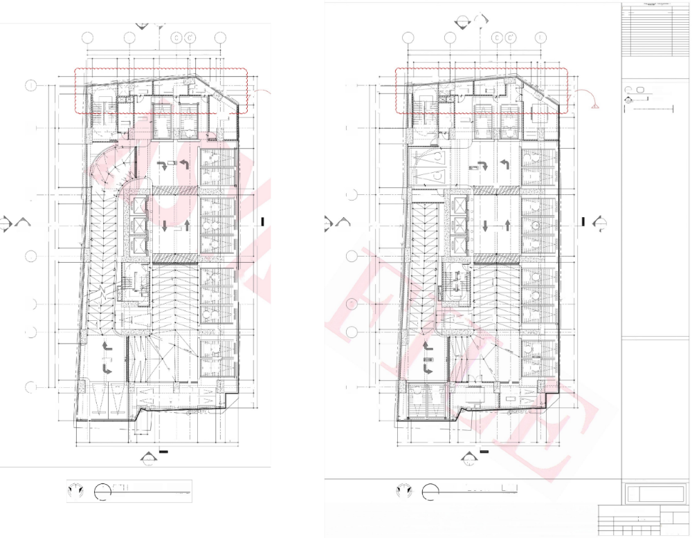**DRAWING REGISTRY**

DESCRIPTION

MARK

△

DATE

**DEC.10,2024**

**INCLINED COLUMNADJUSTMENT**

2 A

2

A-501

A-501 1 402

话

A B D A B

D

17720

17720

6250 I

4036

4036

1942 803

5615

6250 1815

5615

3312 1553 700

1815

995

1031

798

2600

4578

中十

798

3312 1553 700 2600 4130 1478

1942 803 995 1911

8200 800 5400 4143 1665 1288 1848

5848 2072 4620 1203

4900 1900 8950 2199 5822 2098 4555 1000138 1203

42000

。8

¥C

29

LIN E PROPERTY

PROPERTY LINE

LEGEND:

①

四1791

吉

热o

1

STORAGE ROOM

◆HL=18700MN SSL=18700MN

STORAG ROOMi

5120M

o FR

AUX

ROOM 216

二AU×

ROOM

◆HL=18850MM SSL=18800WW

):回 日 

个

u

◆FL-18650M SSL=18600MN

DRAWING NO.

*C.*

①

SHEET NO.

飞

000

4143 665 1293

SHEET TYPE(A/ME/P/FP/S)

BLOWER ROOM

5695

@⑤④

同③ ①⑨ ④③⑨ ①

面39

CUITTING LUNE

大

8920 5695

闻

下

大

⑩ ⑨

⑦ ⑥ ⑤ ④ ③ ② ①

MAICH LINE_

⑥ ⑥ 懊 ⑱ 0

i2②0

BBIN& ENGINEERING

OFFICE

EE ROOM

◆FFL=1850WM

◆SSL=18800MM

EE

FFL=1B70CMM

◆FHL=18700WW 中SSL=18700MM□

ROOMi

过 i @

=23050

+52=18700W

般

6-03

0

0

②

60

5-04)

品

6

②

2

②

5-=230

FE.

EE. 1

0

OMN

6-04)

十-2

◆FL=18700U

SSL-18650M

佛

1% SLOPE

条

1信aOF一

RMP后1o0nH 00R

0298

Gb (十05)

6-05)

6-32)

(6-06

FL=1855

*5SL=18550

1x50F

5400

E

3FO下

13s.OPEE

神

=22900MM

5-08) 6-0

6-0)

6-31)

6-0

第 SOPE

信 1 0FEC

z

1%SLOPEE

3

4900 1900 8950 5928 213

1830s

品

③

30

STORAGE ROOM

G10(5-09)

N 门

6-09)

PE

PE1

>

>

6-0

日

A

8200

7350 3750 6400 8200

8200

A

2 402

A

5-12( (5-11)

PROPERT

生3

PROPERT

1

A-501

DRO 中-0FF

1

A-501

DROF -OFF

SEE SECTION'A

SEE SECTION'A

PE

6-2 6-

6-5) 6-14)

2 402

401

1270

(

40315

SLOPE-14.69%

44265

40315

44265

G⁵ (5-14)

006

0 1

o s

不

>

SEx1

*SE×*

4

8950 300

4

品

UP

" 三4

PROPERTY LINE

JP

DM

2

2刚愉i析

⑤ (5+ 5

7350 3750 6400

03

e④⑥

24=

G-1 6-16)

6- (6-18)

6-2) 6-209)

4

② ⑤-

① ②

④ 严

SLOPE

⑥①

百

8950

帝日

51(6-18)

0.&

3

F.E.2

5=23046N

中S 9850

>

⑤

FE.2

5

3d07

= E g

脚

(5-21) 5-20)

>|

零

Gh)

6-2)

BLEND=7%

SLOPE= 4%

008 0009

BLEND=7%

S.0PE=

出

6

RAMP DOWN TO 4THL00R

RAMP DOMN To 5TH;FL0O

**KEYPLAN:**

神

18 SLOPE

8 S0PE

(6-23) 2

0009

5-2)

5-2

SLOPE: 4%

S⁵260DM

1 185o

◆ L- 17950MM

5SL=7950WM

6-25) 6-24)

% S03

3700 1400

00L

004L

(5-26 4

常 中 贯

第

◆FL=18150MM S2=18150

@ @

⑦

*6D*

6-29

6-2 6-26)

0

②

MOTORCYCLE- PARKING SLOT

◆RL=2500MM

◆SSL=22500WN

MOTORCYCLE

BLOWER

ROOM I

PARKING SLOT

2000

2000

03

3700

6-28

BICYCLE 02 RACK

3

57°

WRTENDIMENSIONSONTHESEDRAWINGSSHALHAVEPRECEDENCEOVERR HESILLAT. TM(ARCHITECTURALEaCHANICAL,ETCusReAN2oNAu,.5TRUC)SHALTURAL,BESUBJECoaosa5ANITARY,ELECTRICALTFORVERIFICATIONsecnano0s,

157级 2o

INE

NE

子

血

中

dPROPERTY LINE dPROPERTY LINE

$05 880

1772 5169 100 2400 5740 2400 1260 1710 1772 5169 1100 2400 5740 2400 1260 1710

21551 21551

A

A

1 401

1

401

S S

FLOOR PLAN

6TH

SCALE:

F L○OR

P

AN

1:100 MTS

b

SCALE:

2

A 304

3t ①

N

M

M

3 十

四N

1:100 MTS

A 304

DATE

|  |  |  |  |  |  |  |  |  |  |  |  |  |  |  |  |
| --- | --- | --- | --- | --- | --- | --- | --- | --- | --- | --- | --- | --- | --- | --- | --- |
| **△SYA** | SEAL  REPUBLIC ACT 9266 THIS DRAWING ACTING AS AN  PRSOPEUMENToF ASYA DESYiC PARINER. DuSsucn MEp | NOTE  WRITTEN DIMENSIONS ON THESE DRAWINGS SHALL HAVE PRECEDENCE  OVER SCALED DIMENSIONS.CONTRACTORS SHALL VERIFY AND BE  RESPONSIBLE FOR ALL DIMENSIONS AND CONDITIONS ON THE JOB.THE | DESIGNER  ALLAN C.CHUA | | **STRUCTURAL** **E**  **UG** **uct** | **NGINEER**  ROBERT CHRISTOPHERA.NIEBRES  STRUCTURALENGINEER | **SANITARY** **ENGINEER**  JU **AN** **CARLO** **NORBERTE** | **FIRE** **PRO** **ENGIN**  **WILFRED** A | EER  **BROGENA** | | **ELECTRICAL** **ENGINEER**  **STEPHEN** **NAPE**ŇAS | **MECHANICAL** **ENGINEER**  WILFRED ABROGENA | **PROJECT** **TITLE** **AND** **LOCATION**  GALERI **ES** **TOWER** **MANILA** | **LAND** **OWNER** **&DEVELOPER** | SHEET  CONTENT |
| APLAGCE ASIA CGMPLeR,CBP-YA 72/85-05  EMAlL ADD.asyo@usyadeslgn.com.ph | SAID DOCUMENTS FOR USE IN THE REPETITION OF AND FOR OTHER  PARILECTSRIN WHDLEWTHou CHER  CONSENT.ALL DRAWINGS ARE TO BE  RETURNED WHEN NO LONGER IN USE. | DESIGNER MUST BE NOTIFIED IMMEDIATELY OF ANY VARIATIONS FROM THE DIMENSIONS AND CONDITIONS SHOWN BY THESE DRAWINGS.  ANY DISCREPANCY ON ALL DRAWING &SPECIFICATIONS  (ARCHITECTURAL,STRUCTURAL,SANITARY,ELECTRICAL &MECHANICAL) SHALL BE SUBJECT FOR VERIFICATION AT THE ARCHITECT's OFFICE BEFORE IMPLEMENTATION. | REG.NO:0023165  PTR.NO:8453438 | ARCHITECT  TIN: 289-222-941  DATE: 01-03-2024 | 2302C East Tower P.SE Centre,Exchonge eodo tos cmcl2)47010 Emi Adties  ~~~  . | -  REG.NO.011903TIN 273-548-500  PLACE MAKATICITY | SANITARY ENGINEER  REG.NO:0002835 TIN: 319-240-799  PTR.NO:8453437 DATE: 01-03-2024 | MECHANICA  REG.NO:0004781  PTR.NO:8453436 | L ENGINEER | | ELECTRICAL ENGINEER  REG.NO:0004290 TIN: 242-781-694  PTR.NO:8453439 DATE: 01-03-2024 | MECHANICAL ENGINEER  REG.NO:0004781 TIN: 215-380-265  PTR.NO:8453436 DATE: 01-03-2024 | NATIVIDAD LOPEZ STREET COR.CABRAL STREET,MANILA | **GRAND** **TAIPAN** **LAND** **DEVELOPMENT,INC.** | CADD |
| TIN:  DATE: | 215-380-265  01-03-2024 |
| CHECKED |

MAR 2024

GRF

ER

ER

**DRAWING PHASE:**

**FOR**

ASYA ASYA

ASYA

5TH &6TH FLOOR PLAN

SCALE AS SHOWN PROJ#

T T T T

**CONSTRUCTION BULLETIN**

**SHEET NO.**

A 304

TOTAL SHEETS

T

173

APPROVED

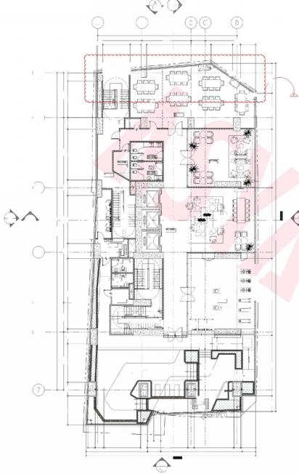

WRTENDIMENSIONSONTHESEDRAWINGSSHALHAVEPRECEDENCEOVERLLAT.SY TM(ARCHITECTURAECHNICAL,ETCausReAN2oNAuL.,5TRUC)SHALLTURAL,BESUBECToaosa5ANITARY,ELECTRICALFORVERIFICATIONsecnano0s,

SEESECTION8

8920 5695

6434 1486 4649

型别

3807

7420 4588

40315

3750 6400 8200

8950 1900 6100 20

ROPERT

4

三

号告

年

告告

PROPERTY LINE

0006

9750

44265

此==二

7350

4900

7700

3700 1400

2000



s

1 7

N

A 305 SCALE:

N

PL AN 1:100 M

LOOR

F

M

3

2

402 A-501

B

17720

6250 I

700 8208

4.

③

飞

FUNCTION/MEETING RO0M

(VERIFY INTERIOIR)

L=29600MM

5L=29550WN

◆HL=29600WM 5Q=29550MM

F.E.1

FEOMAELE

CO-WORKING

52=29550M

2050

FHL=29600NM ◆5SL=29550MM

UP

② ③

*PEX*

.0

2-

Fi2_

uPdJ

RESIDENT'S

LOUNGE

*PEX*

摄

+SS=29550M

SEX₁

中FFL=29600WN

552=29550NW

EE

4

中

MALE

HANGiNG

中 FL=29450WM

EMALE HAN NGING

OLE

二 空 7 克

FITNESS GYM

◆FL=29600W

S-29550MM□

空

F.E.

◆ 册 2 9 6 0 0

中SL=29550N ②

国

和

6

8%SLOPE

POOL

(VERIFY LANDSCAPE)

on

36

*TAN形*

157

INE

dPROPERTY LINE

805 880

800

1685

2155

A

1

00014

列望⑥药图

N 二

④9⑥

3鱼鱼页应鱼43

③立逐西霞0应②

A

5615

3462 1403

1815 4036

95

中 798

2745

1911

peoPERTYLIN

①

②

4

dROREF

五 图

④ DN

JANITOR ROOM

AUX ROOM

◆SSL=29700MM

3

_

⑤ 面

3-

i4_ 画

A

2402

A

① _

②

1

A-501

SEE SECTION'A

2

r AUX

ELEVATOR LOBBY

⑭20_

_

40V

P

ROOM

26o

SS=29400M

DN

PUMP ROOM 中FL=29400W

◆SSL=29350MM

⑤

古

①

⑥⑤

(VER/FY LANDSCAPE)

900 115

800

900

5050

1860

1710

5200

4690

7798

10358

401

SEE SECTION8

40315

3750 6400 8200 8920 5695

3750 5999 2601 7350 1500 8200 2963

PROPERT

N7

ALLWAY

OPER

4075 3000 3000 3000 3150 3475 1500 7451 2103 1152

34565

7350

0009

A

240

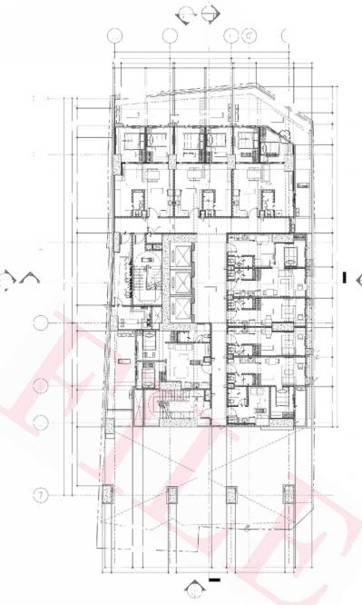

A

402

B

17720

5615

5297

2723

①

DECK

GARDEN DECK FL=3450WM

◆55L=34400MW

BEDROOM 1

MASTER'S BEDROOM

BDRo

②

DIIN LIVING

UNIT

BR

◆FFL=34600WM

SS=34550MM

KITCHEN

义

*wm*

DECK

◆fL=34600MM

55L34550WN

GHA

E===

UNIT G 1-BR

.E

SS=34

① 2.

P GQxES

1 SEE SECTION'A A-501

圆

JNIT I

iuiui

SEX1

EE RQOM

◆FHL=34700WN

4

wM

圆

8

UNIT J STUDIO

5234650M

5 DECK

UNT-s= 2-BR 1二2_

UNIT K

STUDIO

==

5

◎

50M

*do*

6

ORENT0 BELOW

ROPERTY LINE

中VE

PROPERTYLINE

1500

5200

A

1 401

PROPERTY LINE

DECK

◆F=34450WN GARPEN pEck ◆SS-34400MM

LVING

NITA-B 2-BR

③

A

2402

ELEVATOR LOBBY

513450

2

A-501

D

UNIT C-D 2-BR

UNIT H STUDIO

7000

5050

1860

1860

UNT BR

◆FH=34600MN 55=34550MV

0 枢

中FFL=34600WN 52=34550M

◆H=34450MM

◆SSL=34400MM

GARpEN QECK

dLINE oFL 原LDING ABI

鼻象 园

HAL LWAY

PROPERKY

DECK

FFL=34450MM

◎

◎

④ ⑤ G ⑦

6250

⑥

798

谓二

e3650

⑥⑥

365

800

800

STUDIO

网⑧

S9-34850M

KITCHEN

KITCHEN

◎

◎

◎

DINING

懊

6

2793

4036

2245

3832

5805

1815

1050

2848

6077

7000

回 图

5891

3194

AUx

3221

1710

DINING

340N

露

EN

LIVING

900

900

A

wM

圆

图

DECH

RP

SS5=34550MM

图 ]

000

*PE*

WM

⑩

E.

级

圆

PE

C

O

3

I

A

-

|  |  |  |  |  |  |  |  |  |
| --- | --- | --- | --- | --- | --- | --- | --- | --- |
|  | DRAWING REGISTRY | | | | | | | |
| MARK | | DESCRIPTION | | | | DATE | |
|  | |  | | | |  | |
| △ | | INCLINEDCOLUMN ADJUSTMENT | | | | DEC.10,2024 | |
|  | |  | | | |  | |
|  | |  | | | |  | |
|  |  |  |  |  |  |  |  |
|  | |  | | | |  | |
|  | |  | | | |  | |
|  | |  | | | |  | |
|  | |  | | | |  | |
|  | |  | | | |  | |
|  | |  | | | |  | |
|  |  |  |  |  |  |  |  |
|  | |  | | | |  | |
|  | |  | | | |  | |
|  | |  | | | |  | |
|  |  |  |  |  |  |  |  |
|  | |  | | | |  | |
|  | |  | | | |  | |
|  | |  | | | |  | |
|  | | | | | | | |
| LEGEND: | | | | | | | |
| ① DRAWING NO.  四1791 SHEET NO.  SHEET TYPE(A/ME/PFP/S)  CUTTING LINE  MAICH LINE_ | | | | | | | |
| **KEYPLAN:** | | | | | | | |
|  | | | | | | | |
|  | **DRAWING** **PHASE:** | | | | | | | |
|  |  | | | | | | |
| ASYA  ASYA  ASYA | | **FOR** **CONSTRUCTION** **BULLETI**N | | | |  |
| 7TH &8TH FLOOR PLAN | | | | | | **SHEET** **NO.** | | |
| A | 305 | |
| SCALE AS SHOWN | | | | PROJ# | |
|  | | | | | |
| TOTAL SHEETS  173 | | |
| T | T | | T | T | T |
|  |  | |  |  |  |

DATE

MAR 2024 GRF

ER

ER



S

FL○OR

3十

SCALE:

A 305

N

D AN

1:100 M

2

M

|  |  |  |  |  |  |  |  |  |  |  |  |  |  |  |  |
| --- | --- | --- | --- | --- | --- | --- | --- | --- | --- | --- | --- | --- | --- | --- | --- |
| **△SYA** | SEAL  REPUBLIC ACT 9266  THIS DRAWING ACTING AS AN  PRSOPEUMENToF ASYA DESYiC PARINER.  DuSsucn MEp | **NOTE**  WRITTEN DIMENSIONS ON THESE DRAWINGS SHALL HAVE PRECEDENCE OVER SCALED DIMENSIONS.CONTRACTORS SHALL VERIFY AND BE  RESPONSIBLE FOR ALL DIMENSIONS AND CONDITIONS ON THE JOB.THE | DESIGNER  **ALLAN** **C.CHUA** | **STRUCTURAL**  **L** | **E**  **UC** | **NGINEER**  **ROBERT** **CHRISTOPHERA.NIEBRE**S STRUCTURALENGINEER | **SANITARY** **ENGINEER**  JU **AN** **CARLO** **NORBERTE** | F **IRE** **PRO** **ENGIN**  **WILFRED** **A** | **EER**  **BROGENA** | | **ELECTRICAL** **ENGINEER**  **STEPHEN** **NAPEŇAS** | **MECHANICAL** **ENGINEER**  **WILFRED** **ABROGENA** | **PROJECT** **TITLE** **AND** **LOCATION**  G**ALERIES** **TOWER** **MANILA** | **LAND** **OWNER** **&DEVELOPER** | SHEET  CONTENT |
| **APLAGCE** **ASIA** **CGMPLeR,CBP-YA** **72/85-05**  **EMAlL** **ADD.asyo@usyadeslgn.com.ph** | **SAID** **DOCUMENTS** **FOR** **USE** **IN** **THE**  **REPETITION** **OF** **AND** **FOR** **OTHER**  **PARILECTSRIN** **WHDLEWTHou** **CHER**  **CONSENT.ALL** **DRAWINGS** **ARE** **TO** **BE**  **RETURNED** **WHEN** **NO** **LONGER** **IN** **USE.** | **DESIGNER** **MUST** **BE** **NOTIFIED** **IMMEDIATELY** **OF** **ANY** **VARIATIONS** **FROM** **THE** **DIMENSIONS** **AND** **CONDITIONS** **SHOWN** **BY** **THESE** **DRAWINGS.**  **ANY** **DISCREPANCY** **ON** **ALL** **DRAWING** **&SPECIFICATIONS**  **(ARCHITECTURAL,STRUCTURAL,SANITARY,ELECTRICAL** **&MECHANICAL)** **SHALL** **BE** **SUBJECT** **FOR** **VERIFICATION** **AT** **THE** **ARCHITECT's** **OFFICE** **BEFORE** **IMPLEMENTATION.** | **ARCHITECT**  **REG.NO:0023165** **TIN:** **289-222-941**  **PTR.NO:8453438** **DATE:** **01-03-2024** | **2302C** **East** **Tower** **PSE** **Certre,Echong** **od** **otos** **cco24010** **a** **iroeqnoutoon** | | **e**  **REG.NO.011903** **TIN** **273548-500** **PTR** **NO.1007400** **DATE** **01-0424**  **PLACE** **MAKATICITY** | **SANITARY** **ENGINEER**  **REG.NO:0002835** **TIN:** **319-240-799**  **PTR.NO:8453437** **DATE:** **01-03-2024** | **MECHANICA** **REG.NO:0004781**  **PTR.NO:8453436** | **L** **ENGINEER**  **215-380-265** | | **ELECTRICAL** **ENGINEER**  **REG.NO:0004290** **TIN:** **242-781-694**  **PTR.NO:8453439** **DATE:** **01-03-2024** | **MECHANICAL** **ENGINEER**  **REG.NO:0004781** **TIN:** **215-380-265**  **PTR.NO:8453436** **DATE:** **01-03-2024** | **NATIVIDAD** **LOPEZ** **STREET** **COR.CABRAL** **STREET,MANILA** | **GRAND** **TAIPAN** **LAND** **DEVELOPMENT,INC.** | CADD |
| CHECKED APPROVE |
| **TIN:**  **DATE:** | **01-03-2024** |

D

I [192.168.2.203\production-others\Others-Galeries\05](192.168.2.203\\production-others\\Others-Galeries\\05) SITE FILES\01 Site Concerns\04 Construction Bulletin\2025\02 FEB\CB01\CADFILES\3057th Floor &8th Floor Plan.dwg